Table of Contents

Project Proposal 2

Project Introduction and Overview 2

Project Specifications 2

Project Goal 2

Scope 2

Project Specifications 2

Target Audience 2

Project Plan 3

Project Deliverables 3

Project Tasks and Milestones 3

Resources Required 4

Project Risks 4

Project Report 4

Aim and Introduction 4

Analysis 4

Functional and Non-Functional 4

Non-Functional 5

Design 5

Project Testing 9

System Usability Testing 11

Testing 11

User Manual 12

System Overview 12

System Summary 12

System Configuration 12

User Access Levels 12

# Project Proposal

# Project Introduction and Overview

This project is for Nature Photo Gallery where various publishers who are register can upload the images, manage those images in terms of edit, delete, and checking details.

# Project Specifications

## Project Goal

The main goal of this project is to implement an online web application using Asp.Net. The name of this web application will be “Nature Photo Gallery” In this application, there are admin and publishers. Admin can manage publishers by editing, deleting, and checking details. Also, can edit, delete, and check details for various photos. Moreover, publishers can upload, edit, delete, and check details for images. Admin can register new admin and new publishers can register.

## Scope

The main goal of this application is to implement a Nature photo gallery online application. This project is for 4 weeks.

# Project Specifications

* Secure log in and registration for the publishers
* Secure login and admin registration for admins
* Publisher can upload, edit, delete photos successfully
* Admin can manage the publishers and photo gallery

## Target Audience

* **Publishers:** The main target audience for this project will the people who are willing to upload images on the Nature photo Gallery. It can be the nature lovers' age group can start from 10 years and can go up to 100 years and more. As there is no age for hobbies and interests.

# Project Plan

## Project Deliverables

|  |  |
| --- | --- |
| **Deliverable** | **Description** |
| Project Planning Documentation | This document. Introduces the project and elaborates its details and requirements. It also states the need to do the project. |
| Project Coding | The application being made. Marking will be based on the GUI, functionality, implementation, and testing. |
| Implementation | This document elaborates on the projects details as well as its analysis, design, and implementation. |
| Final Presentation | This includes the final documentation of the project. |

## Project Tasks and Milestones

|  |  |  |  |  |  |  |  |  |  |  |  |  |  |  |  |  |  |  |  |  |  |
| --- | --- | --- | --- | --- | --- | --- | --- | --- | --- | --- | --- | --- | --- | --- | --- | --- | --- | --- | --- | --- | --- |
| Project Stages | Major Activities | Week-1 | | | | Week-2 | | | | | Week-3 | | | | | | Week-4 | | | | |
| Planning | Technology Research |  |  |  |  | |  |  |  |  |  |  |  |  |  |  |  |  | |  |  |
| Kick-off Meeting |  |  |  |  | |  |  |  |  |  |  |  |  |  |  |  |  | |  |  |
| Project Proposal |  |  |  |  | |  |  |  |  |  |  |  |  |  |  |  |  | |  |  |
| Proposal Documentation |  |  |  |  | |  |  |  |  |  |  |  |  |  |  |  |  | |  |  |
| Phase-1 | Database Design |  |  |  |  | |  |  |  |  |  |  |  |  |  |  |  |  | |  |  |
| User Interface Design |  |  |  |  | |  |  |  |  |  |  |  |  |  |  |  |  | |  |  |
| Phase-2 | Identity framework implementation |  |  |  |  | |  |  |  |  |  |  |  |  |  |  |  |  | |  |  |
| Admin Implementation |  |  |  |  | |  |  |  |  |  |  |  |  |  |  |  |  | |  |  |
| Publisher Implementation |  |  |  |  | |  |  |  |  |  |  |  |  |  |  |  | |  |  |  |
| Testing |  |  |  |  | |  |  |  |  |  |  |  |  |  |  |  | |  |  |  |
| Closing | Final Documentation |  |  |  |  | |  |  |  |  |  |  |  |  |  |  |  | |  |  |  |
| User Manual |  |  |  |  | |  |  |  |  |  |  |  |  |  |  |  | |  |  |  |

## Resources Required

* Microsoft 365
* Identity framework
* Asp.Net framework
* Windows Operating System 64-bit Processors
* 8 GB or more RAM.

## Project Risks

The following are the identified high-level risks that might affect the completion and success of the project:

* Project delays may cause a cascading delay in other dependent tasks.
* Project scope and duration may be underestimated.
* The project must have exceptional security for the system contains confidential information.
* The overall functionalities requested may be beyond what the development team can deliver in the given time available.

# Project Report

## Aim and Introduction

The project aims to introduce a Nature Photo Gallery web application which will help users to upload photos of their choice.

.

# Analysis

### Functional and Non-Functional

The functional requirements of this project are divided into types. One for Admin, and one for Publisher.

|  |  |
| --- | --- |
| **Users** | **Functional Requirements** |
| **Admin** | * Login/logout * Register new admin * Manage photo gallery by edit, delete of photos * Manage publishers by edit, delete, and check details. |
| **Publisher** | * Login/logout * New Publishers can register themselves. * Publishers can upload new images, edit, delete, and check details of the existing ones. |

### Non-Functional

|  |  |
| --- | --- |
| **Operational** | * The system should able to run on all web browsers. * The system should be accessible via mobiles |
| **Performance** | * The system should have a 99% uptime |
| **Security** | * Only Administrators have full access to the system * Only Publishers have access to the photo upload feature |

# Design

**Home Page**

This is the landing page of the web app. It consists- Home, Gallery, publisher registration, register an admin and login options on the navigation menu. Further, a button view photo is in the center of the header of the home page. Which will navigate to all photos of the web app.

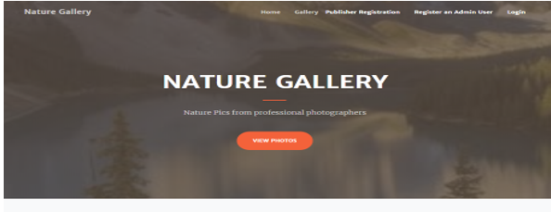

**Login Page**

This page helps the admin and publishers to login to the app by using their valid credentials.

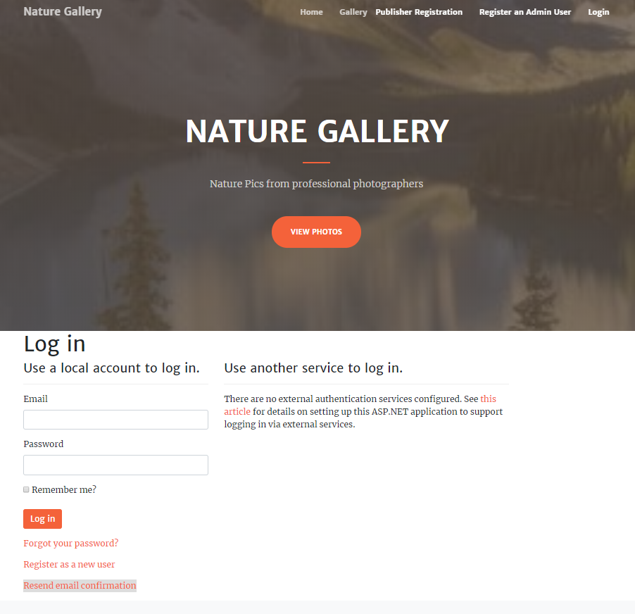

**Gallery Page**

This page consists of various photos of the Nature photo gallery app, user can view various images.

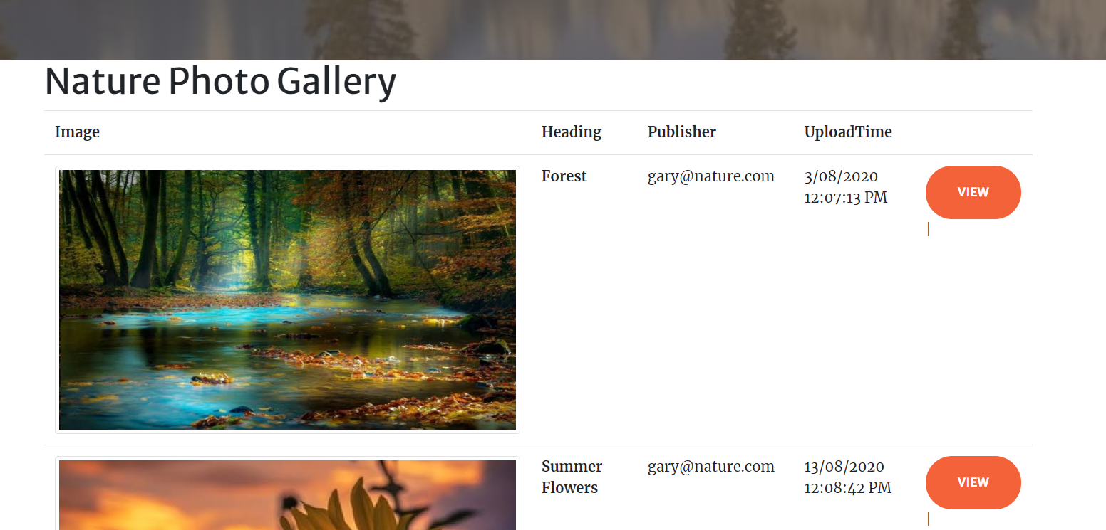

**Nature Gallery Admin View**

This page shows that admin can edit, delete and view the details of various images available in the Nature Photo Gallery.

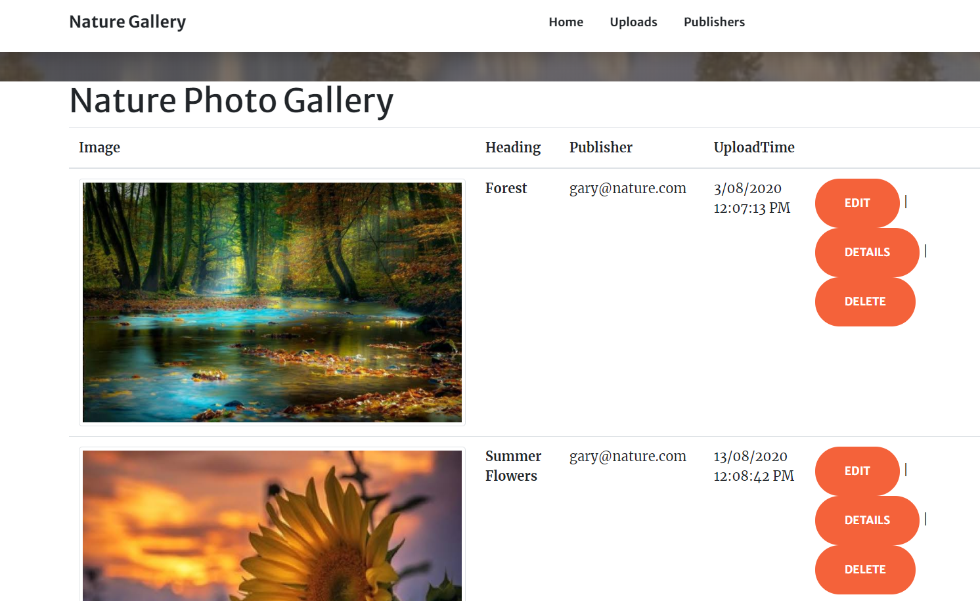

**Publisher Admin View**

This page shows various registered publishers of the web app. An admin can manage all publishers by editing, deleting, and accessing the details.

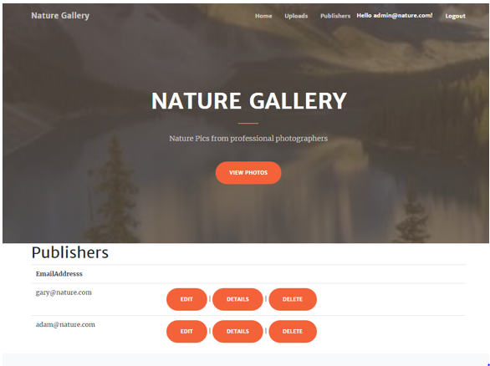

**Publisher Registration Page**

This Page highlights the details which a new publisher has to fill to register with the Nature phot gallery.

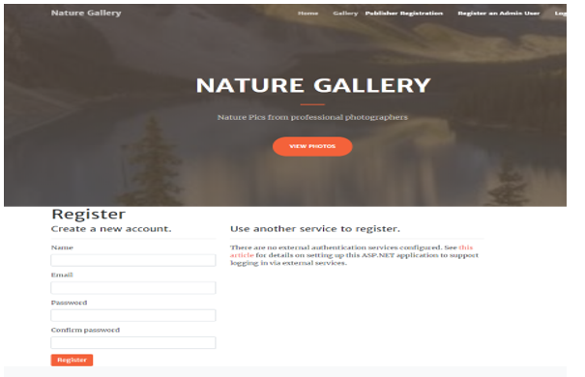

**Nature Gallery Publisher View**

This page shows the publisher view of the Nature Photo gallery app. Here publisher can upload an image, edit and delete existing ones and also can check the details of the ones that are already uploaded.

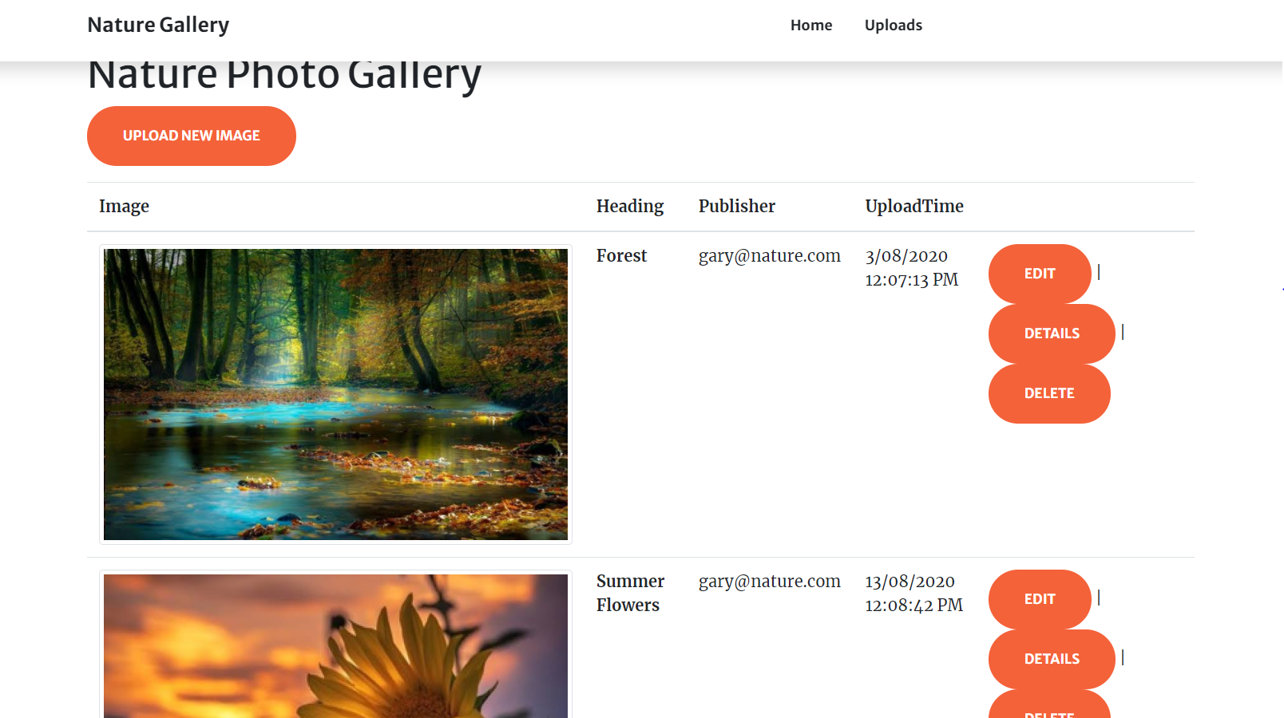

|  |  |  |  |  |  |
| --- | --- | --- | --- | --- | --- |
| **Test Case ID** | | TC1 | | | |
| **Test Case Title** | | verify the launching of web app | | | |
| **Pre-Conditions** | | Browser the web app | | | |
| **Post-Conditions** | | Website should be launched successfully | | | |
| **Step No.** | **Test Step** | **Input Data** | **Expected Result** | **Actual Result** | **Test Step Result** |
| 1 | open [project](http://www.authordeus.azurewebsites.com) in Visual studio |  | website index page should open | As Expected | Pass |
| 2 | Close the Home page by clicking close button on browser |  | Website should close. | As Expected | Pass |
| 3 | Manually Launched website using localhost |  | website home page should open | As Expected | Pass |

# Project Testing

**Test Case 1**

**Test Case 2**

|  |  |  |  |  |  |
| --- | --- | --- | --- | --- | --- |
| **Test Case ID** | | TC2 | | | |
| **Test Case Title** | | Verify login with valid username and password | | | |
| **Pre-Conditions** | | username and password are saved into the database | | | |
| **Post-Conditions** | | The user is validated with database and successfully login to the account. | | | |
| **Step No.** | **Test Step** | **Input Data** | **Expected Result** | **Actual Result** | **Test Step Result** |
| 1 | Launch web app in a new browser window |  | Login screen of website should display. | As Expected | Pass |
| 2 | Enter valid User id and correct password | User : admin@nature.com  Password: 1qaz2wsX@ | Entered User Id should display in "User Id" field  Enter Password should be masked as "*" | As Expected | Pass |
| 3 | Click "Login" button |  | Home page should open and user id should display at the top right side on the page. | As Expected | Pass |
| 4 | Enter valid User Id and incorrect Password | User : admin@nature.com  Password: 1qaz2wsX | Error Message should appear for incorrect password. | As Expected | Pass |
| 5 | Enter Invalid User Id and correct password | User : ad@nature.com  Password: 1qaz2wsX@ | Error Message should appear for incorrect User ID. | As Expected | Pass |
| 6 | Enter Invalid User Id and incorrect password | User : amin@nature.com  Password: 1qa | Error Message should appear for incorrect User ID and password | As Expected | Pass |

**Test Case 3**

|  |  |  |  |  |  |
| --- | --- | --- | --- | --- | --- |
| **Test Case ID** | | TC3 | | | |
| **Priority** | | High | | | |
| **Test Case Title** | | Verify website Home Page interface | | | |
| **Pre-Conditions** | | Open website in a browser | | | |
| **Post-Conditions** | | Home page interface should correct and working correctly. | | | |
| **Step No.** | **Test Step** | **Input Data** | **Expected Result** | **Actual Result** | **Test Step Result** |
| 1 | Verify Home Page |  | should display all options | As Expected | Pass |
| 2 | Verify navigation bar |  | Following options should be available in navigation bar   * Home * Gallery * Publisher Registration * Register an Admin * Login | As expected | Pass |

## System Usability Testing

### Testing

**Tester 1**

|  |  |  |  |  |  |  |
| --- | --- | --- | --- | --- | --- | --- |
| **Tester –1** | | **Answer Scale** | | | | |
| **No.** | **Question** | **Strongly Disagree (1)** | **Disagree (2)** | **Normal (3)** | **Agree (4)** | **Strongly Agree (5)** |
| 1 | I think that I would like to use this system frequently |  |  |  |  |  |
| 2 | I found the system complex |  |  |  |  |  |
| 3 | I thought the system was easy to use |  |  |  |  |  |
| 4 | I found the various functions in this system were well integrated |  |  |  |  |  |
| 5 | I thought there was too much inconsistency in this system |  |  |  |  |  |
| 6 | I would imagine that most people would learn to use this system very quickly |  |  |  |  |  |
| 7 | I felt very confident using the system |  |  |  |  |  |

**Tester-2**

|  |  |  |  |  |  |  |
| --- | --- | --- | --- | --- | --- | --- |
| **Tester –2** | | **Answer Scale** | | | | |
| **No.** | **Question** | **Strongly Disagree (1)** | **Disagree (2)** | **Normal (3)** | **Agree (4)** | **Strongly Agree (5)** |
| 1 | I think that I would like to use this system frequently |  |  |  |  |  |
| 2 | I found the system complex |  |  |  |  |  |
| 3 | I thought the system was easy to use |  |  |  |  |  |
| 4 | I found the various functions in this system were well integrated |  |  |  |  |  |
| 5 | I thought there was too much inconsistency in this system |  |  |  |  |  |
| 6 | I would imagine that most people would learn to use this system very quickly |  |  |  |  |  |
| 7 | I felt very confident using the system |  |  |  |  |  |

# User Manual

### System Overview

The name of this web application will be “Nature Photo Gallery” In this application there are admin and publishers. Admin can manage publishers by editing, deleting, and checking details. Also, can edit, delete, and check details for various photos. Moreover, publishers can upload, edit, delete, and check details for images. Admin can register new admin and new publishers can register.

## System Summary

### System Configuration

Nature Photo Gallery is a web application developed using Microsoft Visual Studio 2019. It will run on most modern web browsers and will not require any special system configuration. As a web application, it will require an internet connection to function.

### User Access Levels

Only registered users can access the features of the app. Also, this app has different types of users; each with different access to the web application’s features.

* **System Administrators:** Full access to the system and all functionalities. Full access to all stored data.
* **Publisher:** Access to limited services.